|  |
| --- |
| Uitfasering Stratum-5 (PMO-7902)  Trackerbox Installation and configuration |

|  |  |
| --- | --- |
| Author: | Wambacq Frank |
| Date: | 13/03/2019 |
| Version: | 0.2 |
| Document type: | JDN_Generic_Analysis |

History and Version control

|  |  |  |
| --- | --- | --- |
| **Version** | **Date** | **Remark** |
| **0.1** | 11/02/2019 | Initial version |
| **0.2** | 13/03/2019 | Update after discussing the roll-out method with MSG |
| **0.3** | 08/04/2019 | Update the included trackerbox inventory document |

Table of contents

1 Vessels in scope 3

2 Installation 3

2.1 Network 3

2.2 Power 4

2.3 Serial ports 4

3 Configuration 4

3.1 System 5

3.2 Network 6

3.3 Data communication 6

3.4 Ports 7

3.5 Time synchronization 8

4 Verify communication 8

# Vessels in scope

Trackerboxes are delivered by MSG and must be sent to all of the 88 ships defined in the Excel list “Vessels to install”. Tjis list also defines the priority (1 or 2) and the installation wave.

**Priority**: The vessels in the 1st priority set are those vessels that are currently tracked by Stratum-5. These should be replaced first in order not to lose the tracking functionality. Within a priority set, the bigger vessels get priority over the smaller ones.

**Wave**: Trackerboxes will be delivered in batches of 30 boxes. All vessels have been assigned to an installation wave, taking into account the priority defined above.

# Installation

The trackerbox needs to be sent to the vessel (make sure that CLS is updated)

On the vessel it needs to be installed with following connections

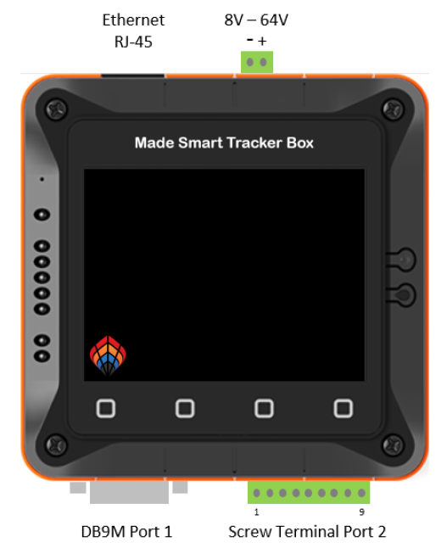

Network

Power

Serial port

Serial port

## Network

Insert a network cable that is linked to a port in the switch that belongs to the machine network

Use DHCP reservations so that the device gets IP Port 177 in the machine network. The Mac address of the trackerbox can be found in document “Jan de Nul TrackerBox Inventory.pdf” where the serial number (shown on sticker on the device) is linked to the mac address.

A firewall rule has been created and rolled out to all vessels with the newest standard (FortiGate) via SR-19030814.:

* Allow to connect via UDP and TCP to data.madesmart.nl:7780 but NOT via Irridium
  + This port is used for the high-frequency data stream
* Allow to connect via UDP and TCP to data.madesmart.nl:8780
  + This port is used for the low-frequency data burst

## Power

Connect to a power source that delivers 8-64 V DC power.

The trackerbox package contains an adaptor to connect the trackerbox to a 220-230V AC source. A separate power input is also provided when a 8-64V DC connection is already available.

## Serial ports

One of the serial ports will be connected to the AIS transponder. The schema below shows how cabling has been done on the BA.



The other serial port will be connected to the GPS receiver. This will be used to keep on tracking the vessel when the AIS transponder has been switched off. This connection is not shown on the example cabling for the BA because it has not been configured this way.

# Configuration

Once the trackerbox is connected to the network and the device IP is properly configured (via DHCP or via fixed IP address), the device settings are available via the configuration page.

To start the configuration, type the IP address of the device in a browser. You will get the logon screen, requesting the password of the trackerbox. The initial password of the trackerbox is madmaster. This password can be changed in the configuration.

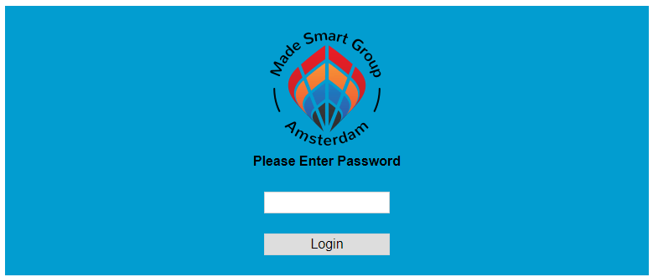

The status screen shows a summary of the current configuration and sending status

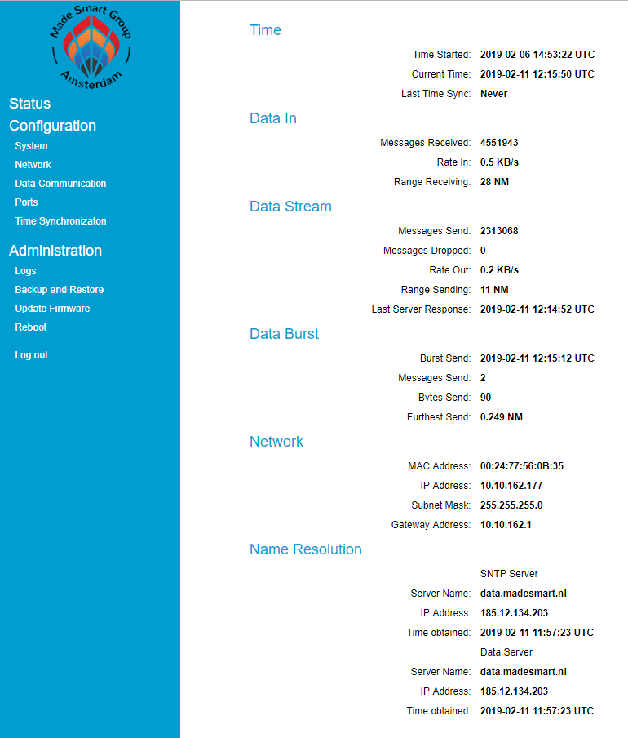

**Note**: Via Administration – Backup and restore, all the configuration settings can be saved to an external file

The standard configuration defined in following Excel has been loaded into the trackerbox upon delivery.

Below are all configuration items, only those marked in Yellow must be changed for all vessels since they have not been defined in the initial configuration

Items marked in green should be checked.

## System

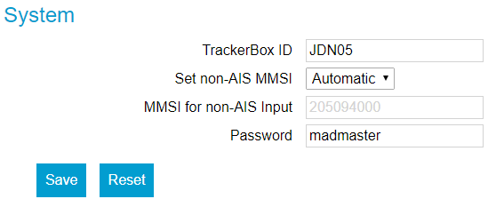

|  |  |  |
| --- | --- | --- |
| Section | Parameter | Value |
| System | Trackerbox ID | fixed value defined by MSG. Leave the value as is |
|  | Set non-AIS MMSI | Automatic |
|  | MMSI for non-AIS input | This should show the own vessels MMSI once data is coming in from the AIS port |
|  | Password | Initial password is madmaster.  Create a new password for each trackerbox. This is the place where you can set this password. Make sure that the new password is also saved in RDM |

## Network

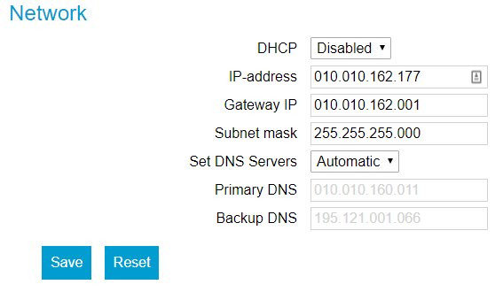

|  |  |  |
| --- | --- | --- |
| Section | Parameter | Value |
| Network | DHCP | Enabled |
|  | Set DNS servers | Automatic |

## Data communication

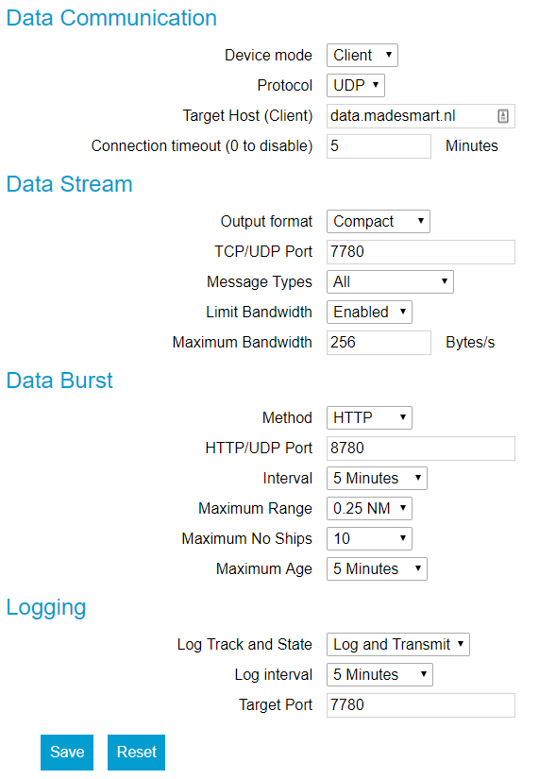

|  |  |  |
| --- | --- | --- |
| Section | Parameter | Value |
| Data communication | Device mode | Client |
|  | Protocol | UDP |
|  | Target host | data.madesmart.nl |
|  | Connection timeout | 5 minutes |
| Data stream | Output format | Compact |
|  | TCP/UDP port | 7780 |
|  | Message types | All |
|  | Limit bandwidth | Enabled |
|  | Maximum bandwidth | 256 bytes/s |
| Data burst | Method | HTTP |
|  | HTTP/UDP port | 8780 |
|  | Interval | 5 minutes |
|  | Maximum range | 0,25 NM |
|  | Maximum No of ships | 10 |
|  | Maximum age | 5 minutes |
| Logging | Log track and state | Log and transmit |
|  | Log interval | 5 minutes |
|  | Target port | 7780 |

## Ports

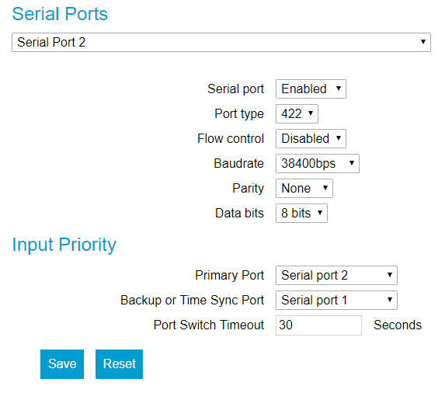

|  |  |  |
| --- | --- | --- |
| Section | Parameter | Value |
| Serial port | Dropdown | Select Serial port 1 or serial port 2 to define to which serial port these settings apply to |
|  | Serial port | Enable the serial port when a device is connected |
|  | Other fields | Set these fields to the specifications of the serial port interface connected to the Trackerbox |
| Serial port | Dropdown | Repeat the settings above for the other serial port |
| Input priority | Primary port | Define the serial port on which the AIS transponder is connected |
|  | Backup or time sync port | Set this to the other serial port |
|  | Port switch timeout | 30 |

## Time synchronization

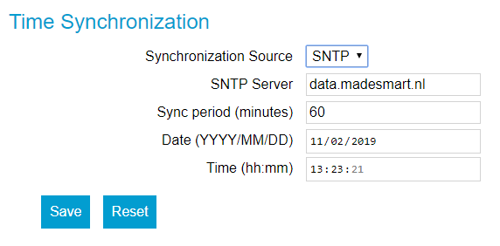

|  |  |  |
| --- | --- | --- |
| Section | Parameter | Value |
| Time synchronization | Synchronization source | SNTP |
|  | SNTP server | Set this to the internal time server of the vessel. When this doesn’t exist, set it to data.madesmart.nl , standard setting = time |
|  | Sync period | 60 |
|  | Date | Define the current date (optional, will be set via SNTP) |
|  | Time | Define the current time (optional, will be set via SNTP) |

# Verify communication

With a browser go to collector.madesmart.nl. Select the details view in the top right corner. Select the vessel in the list on the left. In Report interval, choose Last Hour – Unique MMSI. This graph should show a fluent graph.

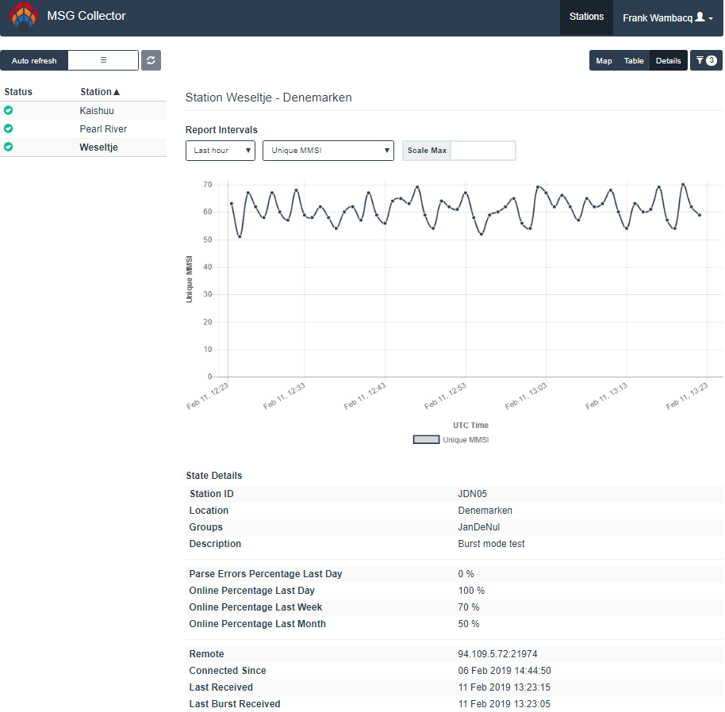

* Verify that the station ID corresponds to the trackerbox ID set in the configuration (section system)
* Location is only indicative – do not bother if this does correspond to the real position
  + The last received position can be found via the map view (top right corner)

This is an example of a graph that show that the communication is lost in the last 6 minutes.

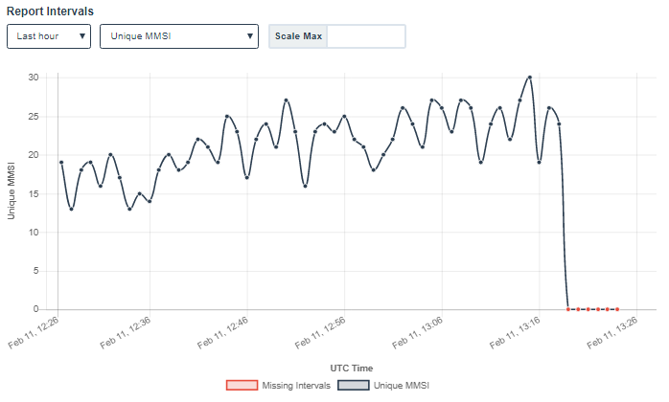

Since the latest version of the collector software, tracker box devices now have a status in the MSG Collector: Active or muted.

**Active**: Configured and installed on the vessel.

**Muted**: Spare devices or devices being shipped to vessels.

Tracker box devices can also be online or offline (transmitting data)

Combining these features makes it easy to create filters. Open the filter function (1) and select the current status (2).

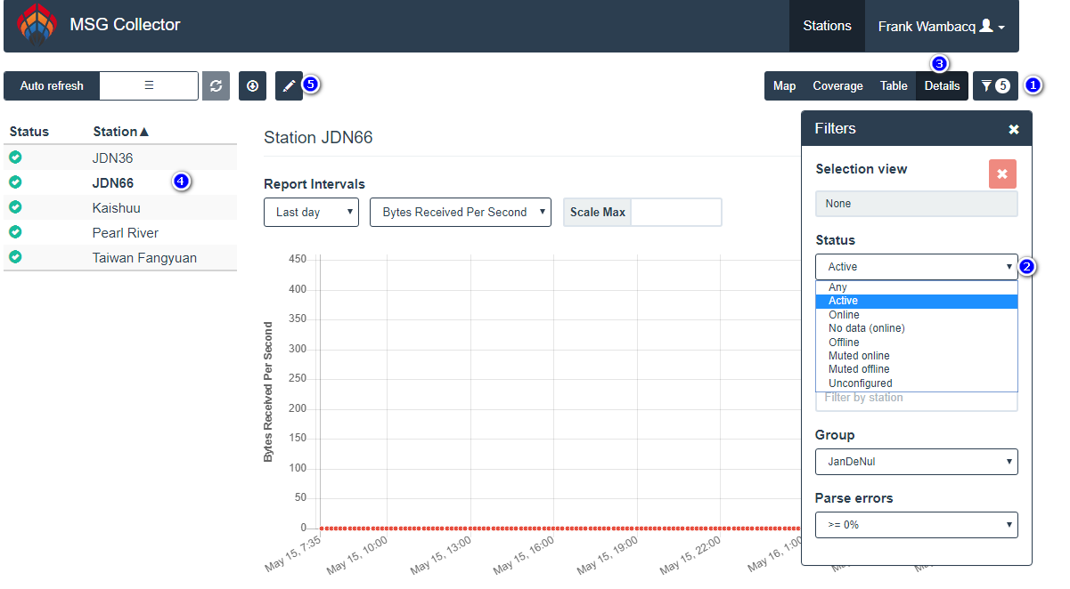

To change the station configuration of a device, open the tab ‘Details’ (3) and select your trackerbox (4). Using the edit option (5), configuration may be edited.

|  |  |
| --- | --- |
|  | * Display name: Name of the vessel * Location: / * Description: / * Mode: active for installed devices, Mute for other devices * Station type: Mobile for vessels, Stationary for AIS stations. |

*\*\*\* End of document \*\*\**